DRAFT OPEN EVENTS ADMISSIONS 2027

COLLEGE | OPEN EVENTS | APPLICATION DETAILS | CONTACT DETAILS
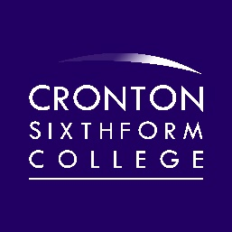 | Saturday 3rd October 10 am – 1 pm  Thursday 8th October 5.30 – 7.30 pm  Wednesday 14th October 5.30 – 7.30 pm  Tuesday 10th November 5.30 – 7.30 pm  Applicant / Year 10 Evening  Wednesday 21st April 5.30 – 7.30 pm | Application Deadline: Friday 11th December 2026  Apply online at:  www.cronton.ac.uk/students/forms/1618form  Interviews will commence in November and continue until March  Any students who miss the last interview session can arrange an appointment after GCSE results day, should there be space on the course they wish to study | Email:  courses@cronton.ac.uk  Website:  www.cronton.ac.uk  Telephone:  0151 257 2022
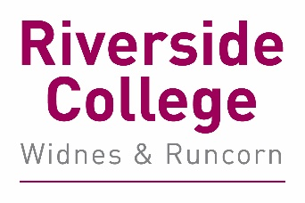 | Tuesday 20th October 5 – 7 pm  Tuesday 17th November 5 – 7 pm  Applicant/ Year 10/ Adult Evening  Tuesday 27th April 5 – 7pm  Adult/ HE and Applicant Evening  Tuesday 8th June 5 – 7 pm | Application Deadline: Friday 11th December 2026  Apply online at:  www.riverside.ac.uk/students/forms/1618form  Interviews will commence in November and continue until March  Any students who miss the last interview session can arrange an appointment after GCSE results day, should there be space on the course they wish to study | Email:  courses@riverside.ac.uk  Website:  www.riverside.ac.uk  Telephone:  0151 257 2022

HOW TO APPLY 2027
- Apply. Online applications open in October and the online application can be found by visiting www.cronton.ac.uk or www.riverside.ac.uk
- Attend an Open Evening.
- Attend interview. This could be in school or in college after school.
- The offer. Places will be conditional subject to GCSEs and additional activities (eg an audition for performing arts).
- New Student Day. Every applicant who has been offered a place will have the opportunity to attend a taster day at college in July.
- Enrolment. Applicants are invited to enrol on their course once they have received their GCSEs.

